Derien Weatherspoon, Hailey Purcell, Celia Murphy

One of the most important things to consider in deciding where to live, how to govern, and what to prioritize in one's life is something that seems quite difficult to measure: What makes people happy? In this project, we set out to predict happiness index values using the The World Happiness Report (2015-2022.csv) the GINI Inequality Index (gini_by_country.csv) and coordinate data (coords.csv). To do this, we used the features GDP, social support, life expectancy, freedom, generosity, trust in government, income inequality, and location. We got most of these features, such as life expectancy, generosity, and trust in the government from the World Happiness Report, a well-known data set that measures overall happiness in each country alongside possible contributing factors. However, we wanted to go beyond this by also looking at location data and the GINI inequality score to see how these factors affect happiness. The GINI index measures income inequality in each country, which we thought would be an important indicator of happiness. The main thing we asked ourselves was: How is each country’s happiness index affected by the factors such as location, inequality, and generosity?
Originally, since we used ten different data sets (the GINI index, the coordinate data set, and data sets from each year measured in the Happiness Report), we first sought to determine if any null values existed. There were none initially, until we converted the variable “trust” into a double, which caused a null value in the combined data frame. We imputed this singular missing value with the mean, which fixed our null value problems for the rest of the data. Moving on, our next step was to find the correlation coefficients for each variable, save for “country” and “country_code”.

Our first goal was to determine which factors had the greatest impact on happiness, and to attempt to use these factors to accurately predict the happiness of a country.
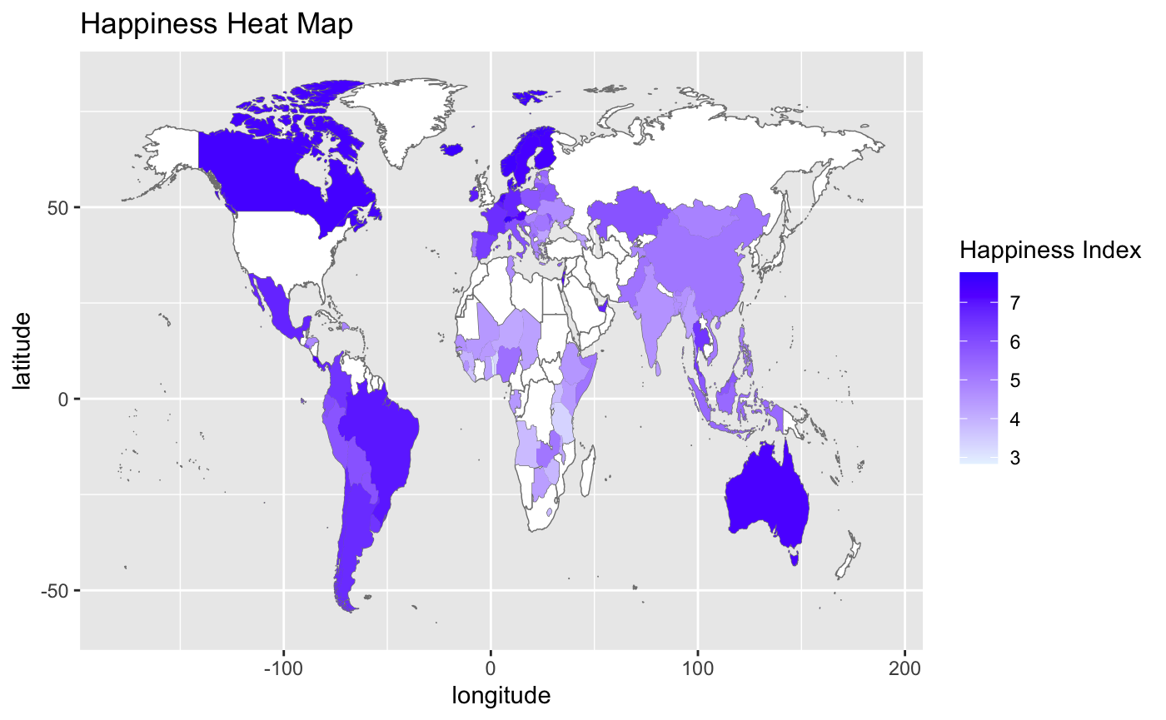

The above heat map shows the true happiness report values from our data set. Through visual analysis, it seems likely that Countries at or below 0 longitude are likely to have a higher happiness score, and that most countries have a happiness score of at least 4.
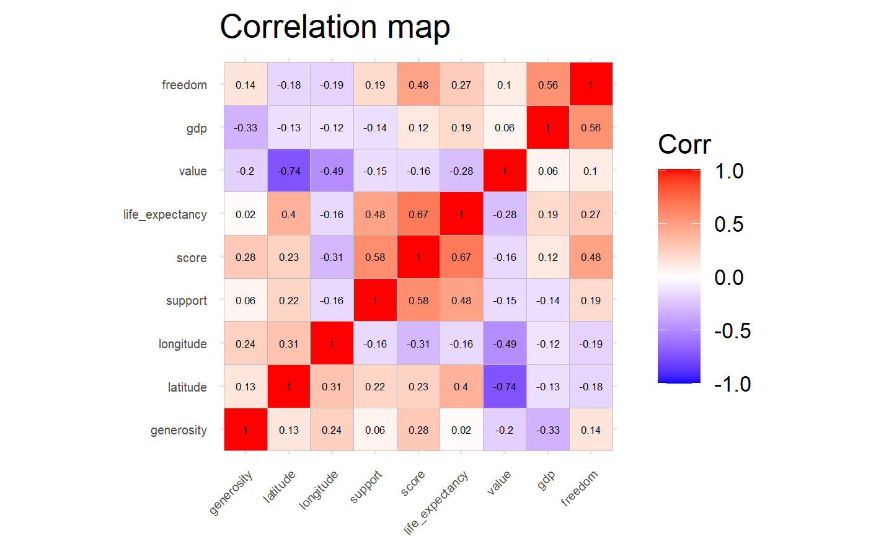
From the correlation plot, we were able to see that life expectancy, support, freedom, and longitude have the highest correlations with happiness score, and, as such, could be the best predictors for this score. When it comes to answering our question, what features are most significant when predicting happiness score, we figured it would be best to attempt multiple linear models, as well as a few tree based models.

We started with a baseline linear regression model using all relevant features to predict Happiness score (-country and country_code). 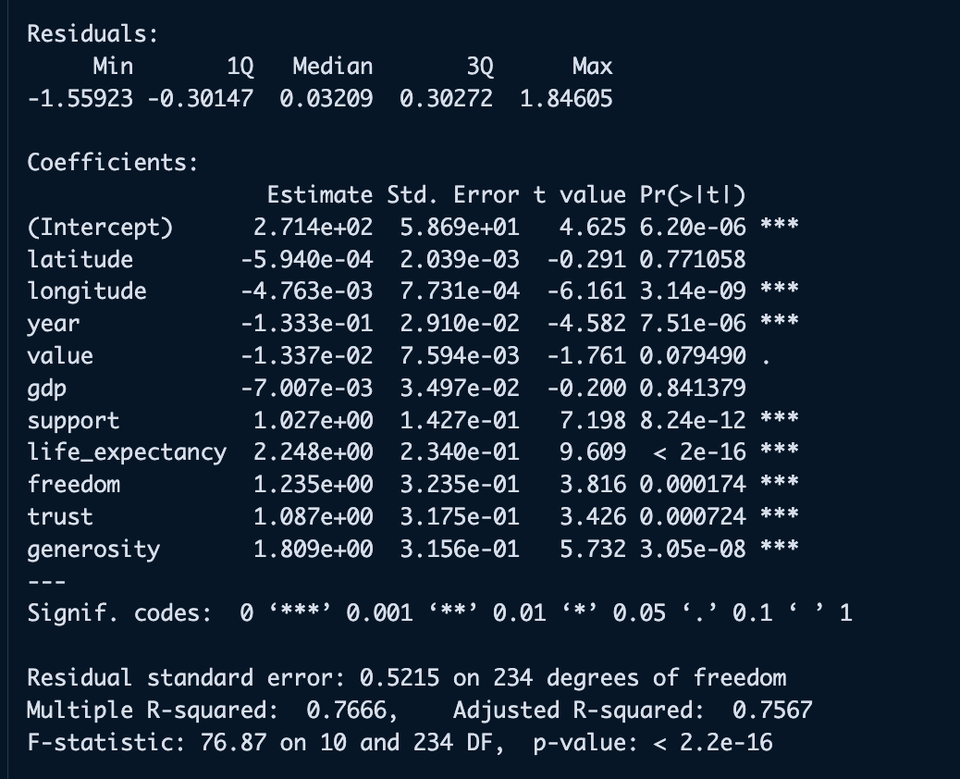

From this summary, we were able to see that there were some insignificant predictors. For our next model, we tested what would happen if we removed these predictors. The initial hypothesis we had was that the R^2 value would get better.
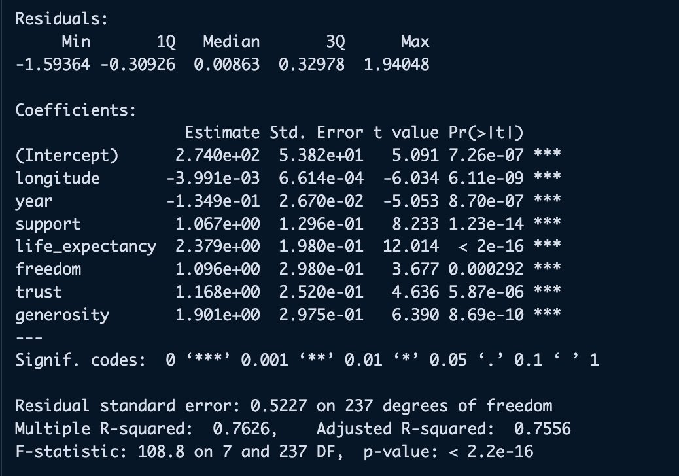

Using this second linear regression model, it seems that all predictors are statistically significant, yet the R^2 got lower. This seems to be intuitive because we know that the less predictors included in a model, the lower the R^2 will be. For further investigation to attempt to improve our model, we applied a log transformation to the linear model with only significant predictors, as well as the model with all predictors included.
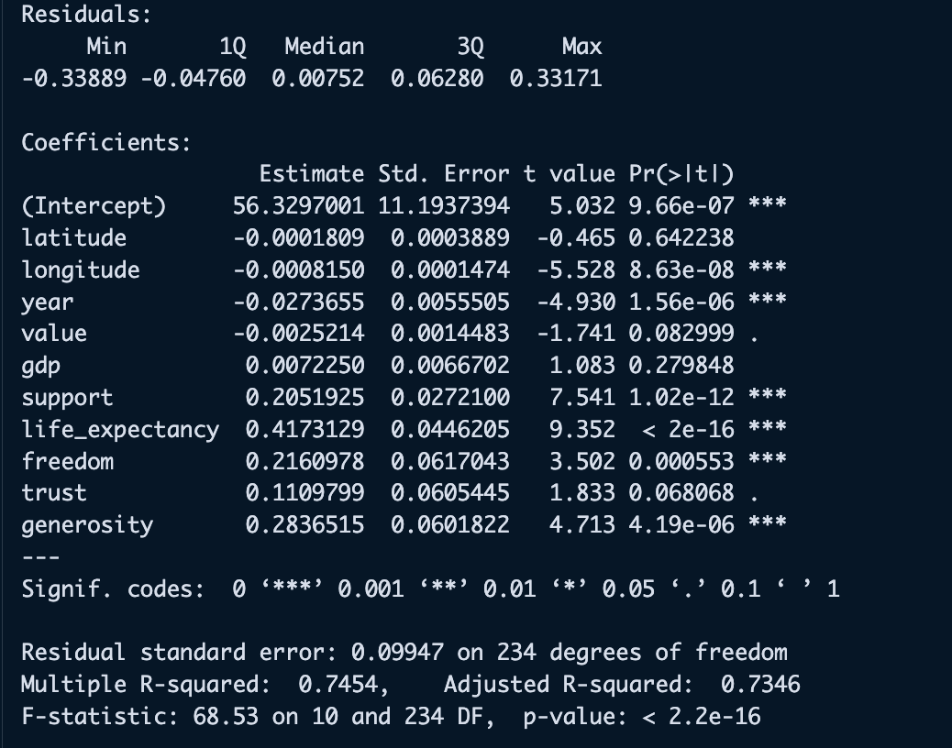
The model above shows a log transformation on the linear model with all predictors included. Evidence shows that it only got worse. Now we can check the significant model with a log transformation.
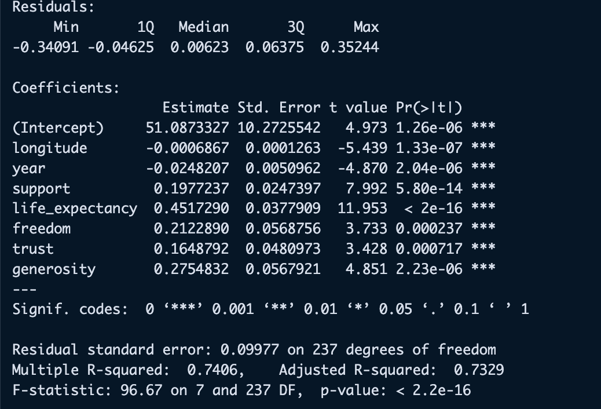
Again, the model only got worse. So, for now, we can analyze the residual plot from the first, and best linear regression model.
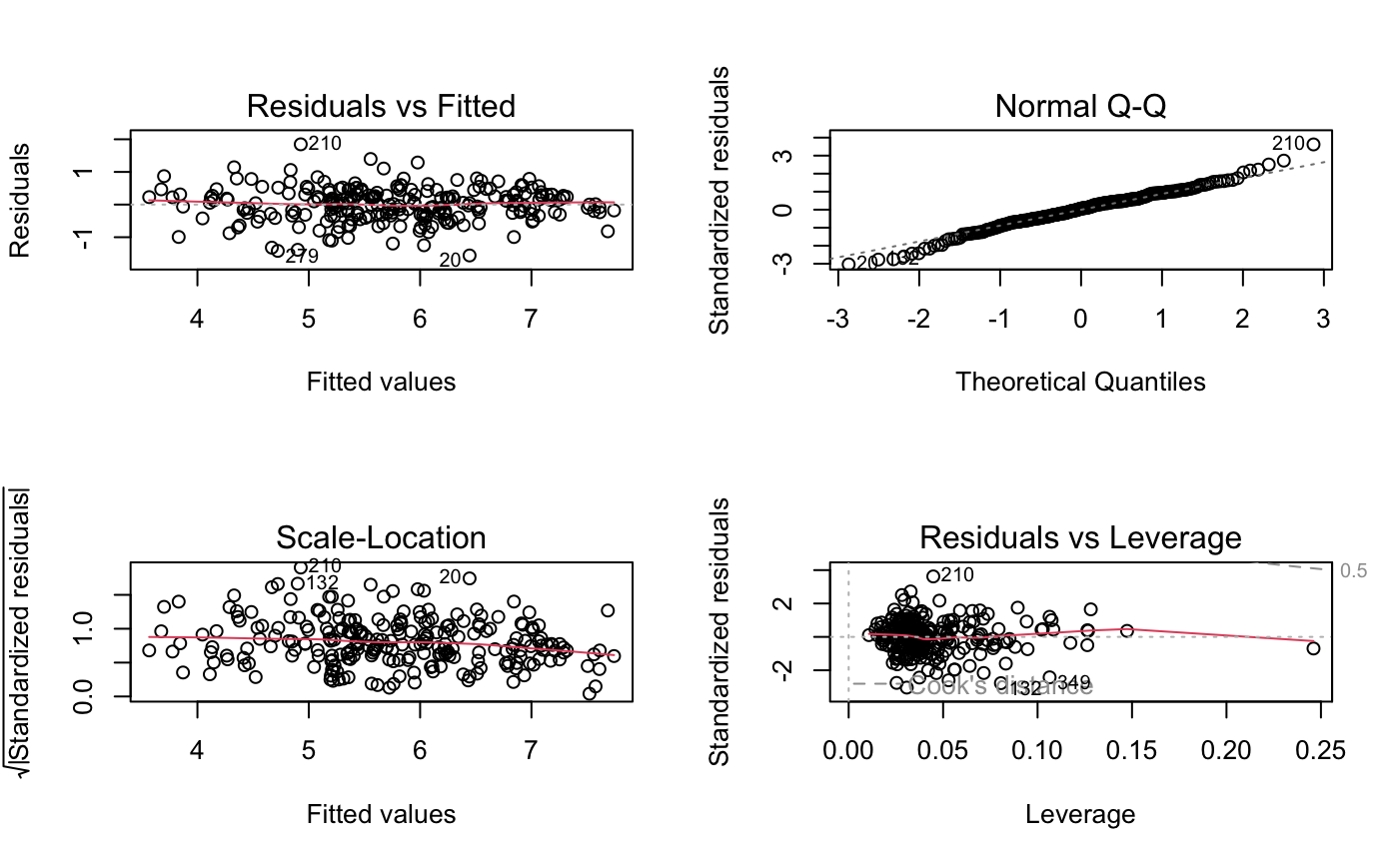

From this residual plot, we can see that there are a few high leverage points, but normality is assumed here, and the residuals vs fitted plot looks to be distributed evenly on both sides, which is a good sign. Furthermore, we have tried to find out whether a shrinkage method or a selection method would help. The first model we tried is a forward stepwise selection model.
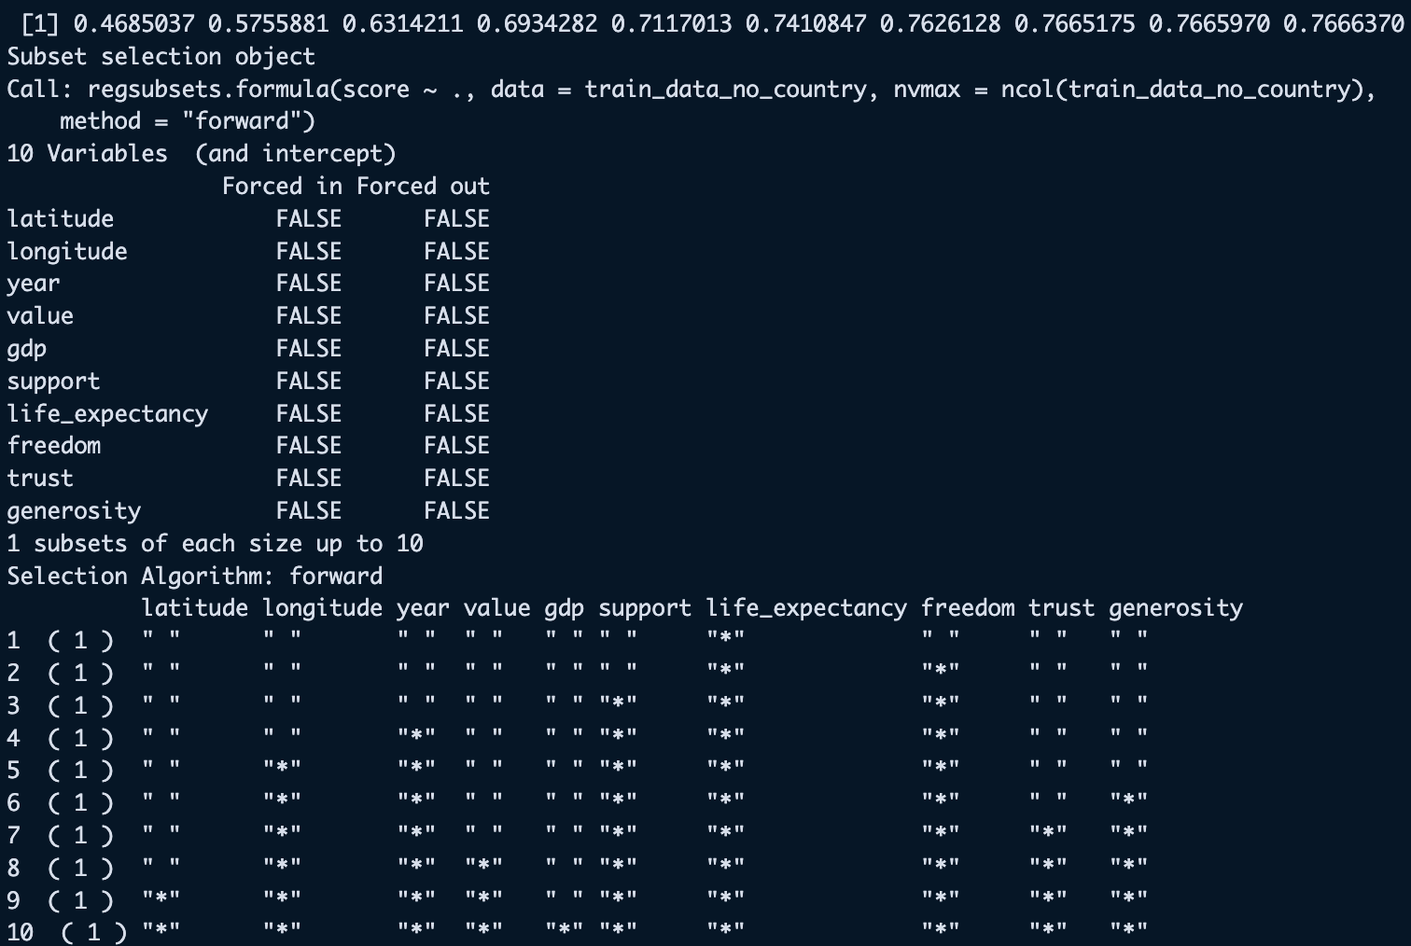

Interestingly enough, the stepwise method has the exact same best R^2 value as the best linear model. Also, the most significant predictor matches that from the correlation plot, this method chose life_expectancy as the most significant. Finally, for the last regression model, Lasso was attempted. 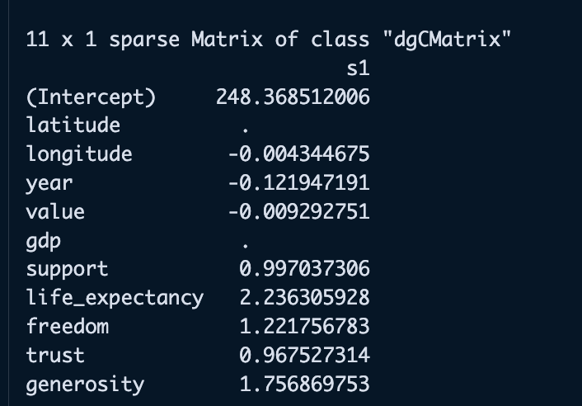The coefficients that the lasso roped in were all but gdp and latitude. This will be an interesting find when it comes to looking at the tree based models, comparing what those decide are the best predictors.

Moving on to the tree based methods, starting with the decision tree model. Our initial thought was that the tree based methods would act better, because they use different input variables to predict a value. This means that the chance at getting a better prediction with data like this would be likelier than using a linear regression method. The first tree we looked at is a decision tree.

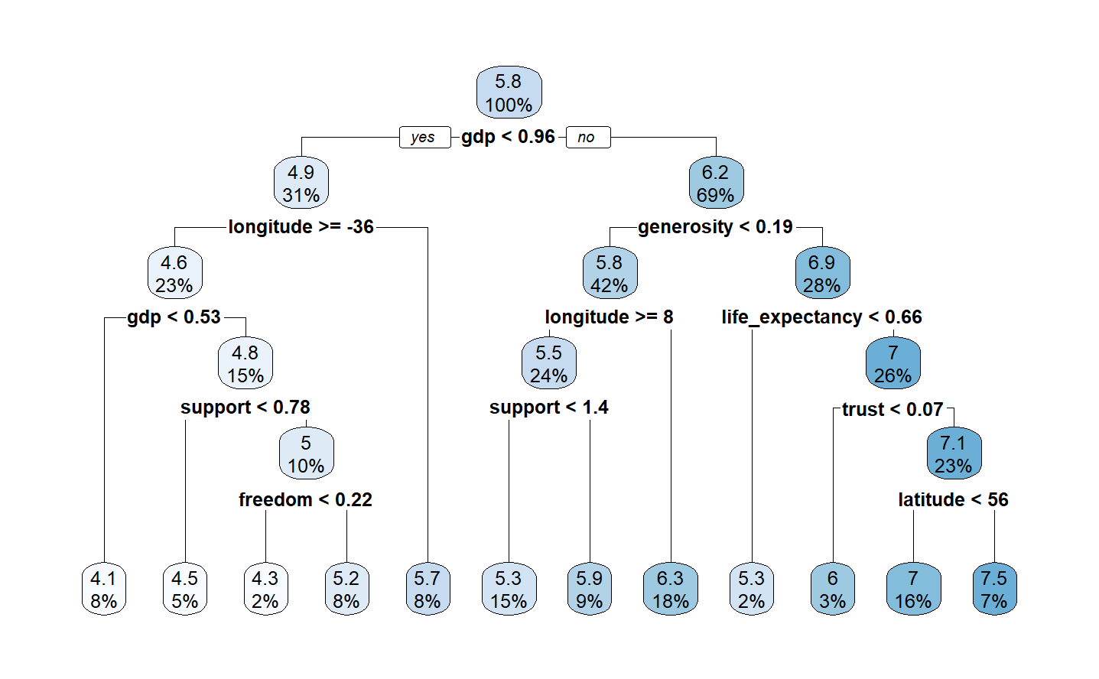
According to the decision tree, it looks like gdp has the most importance when determining happiness score. This was interesting because the forward stepwise model said that gdp was the least significant predictor. Now we can check the random forest model, and what results can be gathered from that.
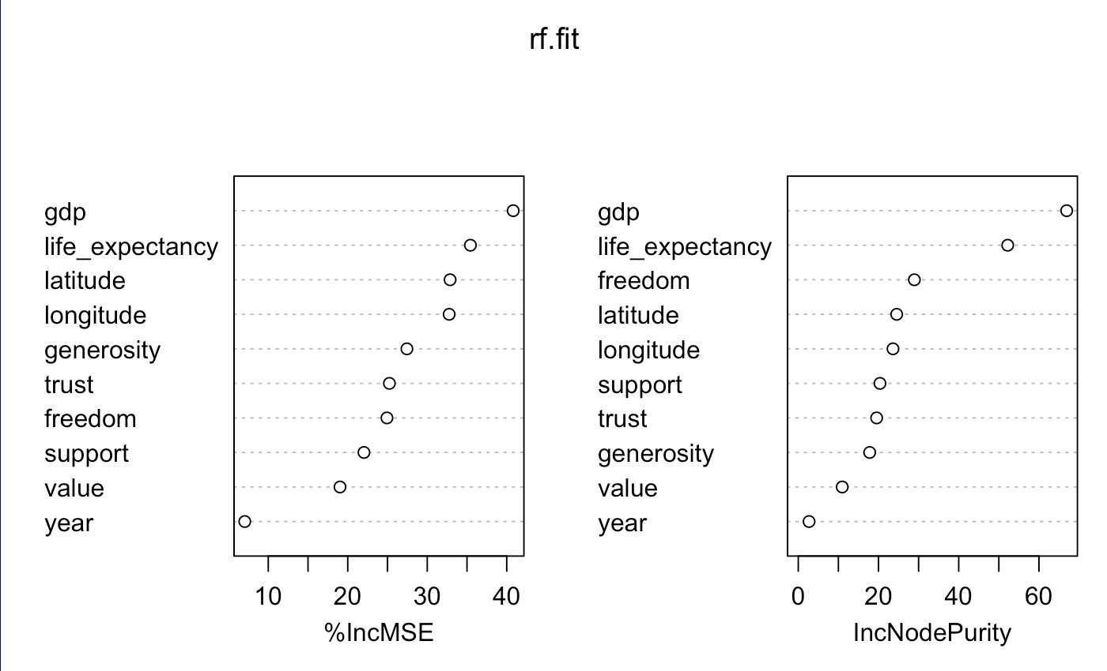

When it comes to explaining the mean squared error, random forest also determined that GDP was the most important predictor. Life expectancy is a close second, which was the most significant predictor when it came to the regression models. With all the models created, we can now compare the MSE for each one.
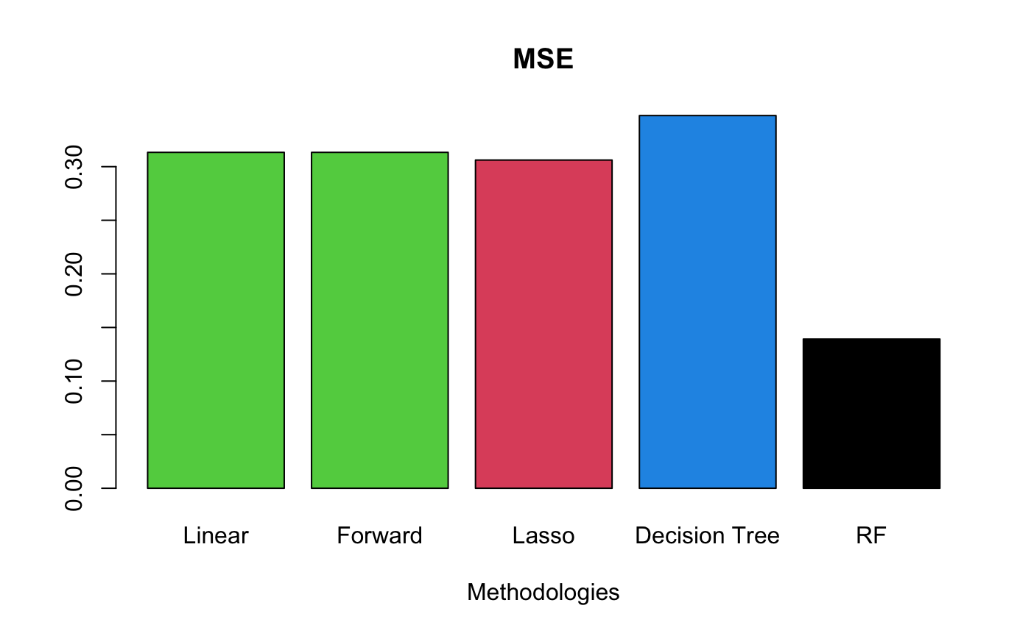

Each method has an MSE of around 0.30, except for the decision tree which is about 0.35, and the random forest model which performed extremely well with an MSE of around 0.14. We can check if this is accurate when looking at the predictions for each of the models. Linear and Forward are the exact same, so will be excluded in the plots going forward..
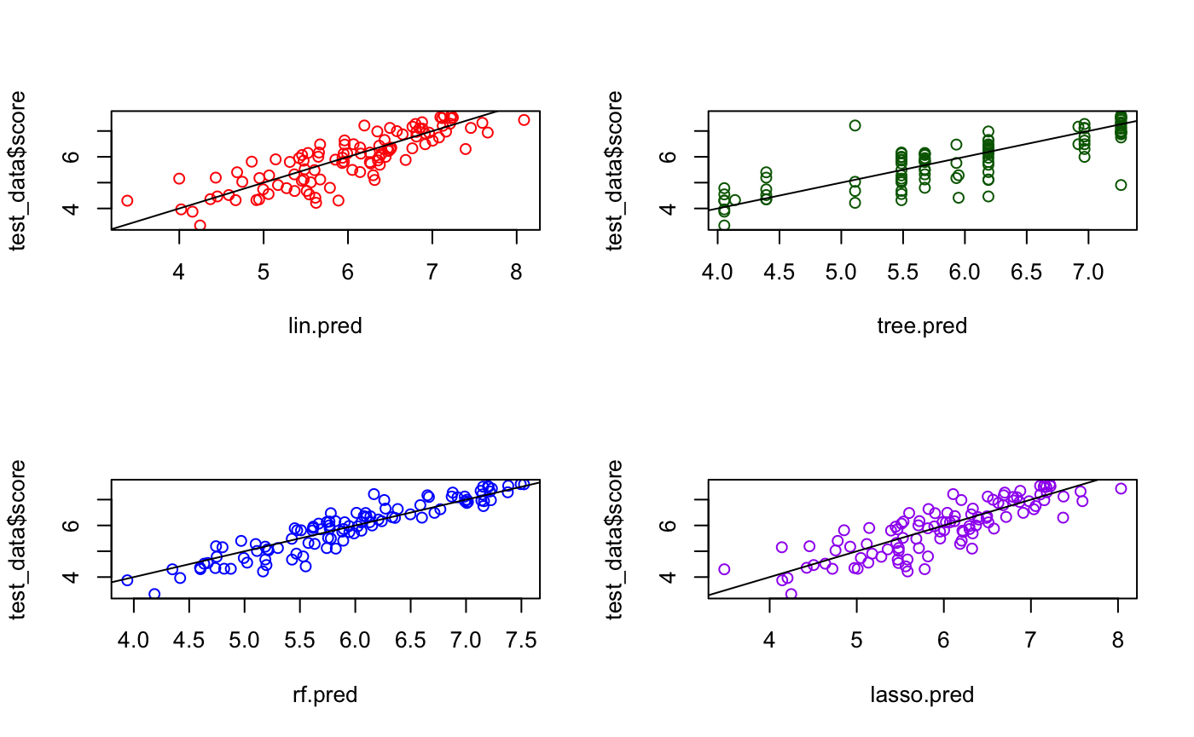

It looks like the random forest mean square error was correct. It is by far the most accurate model in predicting happiness score given the factors around the happiness index.

Our second goal was to determine which factors were most correlated with income inequality (GINI score), and to attempt to use these factors to accurately predict the income inequality of a country.

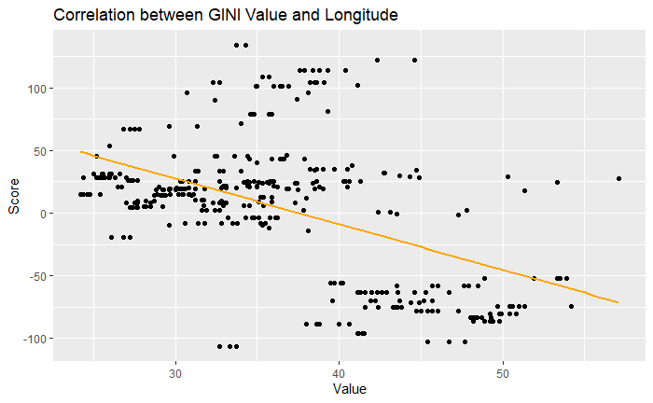
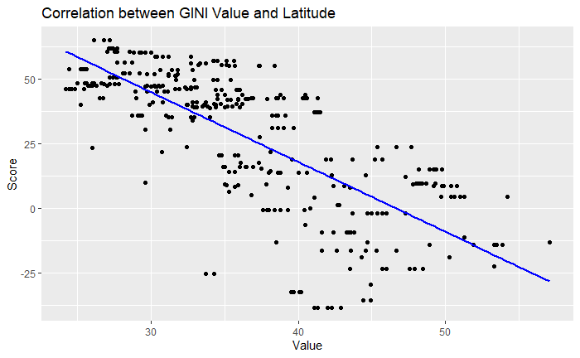

Although there was not a particularly strong correlation between the Happiness Score and the GINI income inequality score, we wanted to use the happiness index to determine what factors are most correlated with income inequality. Somewhat surprisingly, the factors with the strongest correlation with inequality were latitude and longitude.

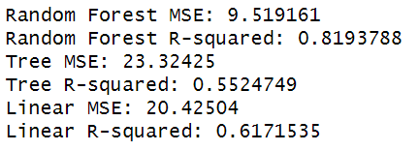
We also ran prediction models for the GINI index, to determine which model would best predict income inequality with the given data. After trying linear regression, decision tree, and random forest, we determined that the random forest model once again had the most success. We determined this by looking at the correlation coefficient and mean-squared error for all three predictions.
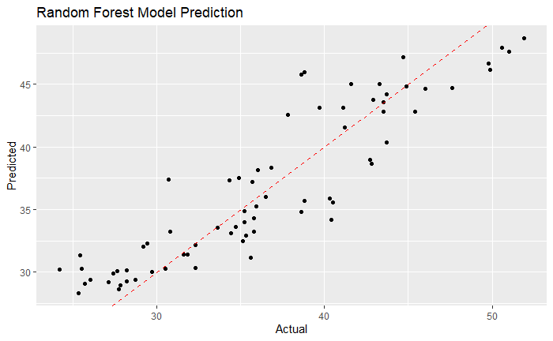

In conclusion, despite our models pretty consistently selecting the same significant features to predict happiness score: longitude, year, support, life expectancy, freedom, trust, and generosity, the best models predicted based on all the target variables, and chose the predictors that the linear models excluded as the most significant features. In the end, longitude, life expectancy, freedom, and generosity were found to be highly significant by all of the models in determining happiness. The random forest produced the best overall predictions out of all models tested. Visually, the random forest happiness values fall extremely close to the true values. Additionally, the random forest model produced the best predictions for income inequality, which had the highest correlation with the factors longitude, latitude, and life expectancy.

# Project Overview

###############################################################################

Explanation of the variables in the data set:

- latitude, longitude: GPS Coordinates for a given country
- country: Countries from different parts of the world
- country_code: Abbreviations for countries
- year: year in which happiness data was collected
- value: GINI index value per country per year, ranging from 0 to 1
- score: Happiness score, which is explained by the following: GDP per capita,
Healthy Life Expectancy, Social support, Freedom to make life choices, Generosity,
Corruption Perception, and Residual error.
- gdp: Gross Domestic Product
- support: Social support
- life_expectancy: Life expectancy
- freedom: How free the citizens of a given country are to make life choices on their own
- trust: How much trust the people have in their government
- generosity: Generosity of the citizens/government

###############################################################################

## Loading Packages

```{r packages, message=FALSE, warning=FALSE}
library(dplyr)
library(sqldf)
library(tidyr)
library(MASS)
library(stringr)
library(ggplot2)
library(ggcorrplot)
library(glmnet)
library(tree)
library(rpart)
library(rpart.plot)
library(leaps)
library(randomForest)
library(magrittr)
```

## Import Data

```{r data}
gini <- read.csv("gini1.csv")
coords <- read.csv('coords.csv')
```

# Feature Engineering

```{r combining happy}
hap15 <- read.csv('2015.csv')
hap16 <- read.csv('2016.csv')
hap17 <- read.csv('2017.csv')
hap18 <- read.csv('2018.csv')
hap19 <- read.csv('2019.csv')
hap20 <- read.csv('2020.csv')
hap21 <- read.csv('2021.csv')

hap15$year = 2015
hap16$year = 2016
hap17$year = 2017
hap18$year = 2018
hap19$year = 2019
hap20$year = 2020
hap21$year = 2021

colnames(hap15) <- c('country', 'region', 'rank', 'score', 'se', 'gdp', 'support',
'life_expectancy', 'freedom', 'trust', 'generosity', 'corruption', 'year')
hap15 <- hap15[,c(1,4,6,7,8,9,10,11,13)]

hap16 <- hap16[,c(1,4,7,8,9,10,11,12,14)]
colnames(hap16) <- c('country', 'score', 'gdp', 'support', 'life_expectancy',
'freedom', 'trust', 'generosity', 'year')

hap17 <- hap17[,c(1,3,6,7,8,9,10,11,13)]
colnames(hap17) <- c('country', 'score', 'gdp', 'support', 'life_expectancy',
'freedom', 'trust', 'generosity', 'year')

hap18 <- hap18[,c(2,3,4,5,6,7,8,9,10)]
colnames(hap18) <- c('country', 'score', 'gdp', 'support', 'life_expectancy',
'freedom', 'generosity', 'trust', 'year')
hap18 <- hap18 %>% relocate('trust', .before='generosity')

hap19 <- hap19[,c(2,3,4,5,6,7,8,9,10)]
colnames(hap19) <- c('country', 'score', 'gdp', 'support', 'life_expectancy',
'freedom', 'generosity', 'trust', 'year')
hap19 <- hap19%>%relocate('trust', .before='generosity')

hap20 <- hap20[,c(1,3,7,8,10,11,12,16,21)]
colnames(hap20) <- c('country','score','gdp','support','freedom', 'generosity',
'trust', 'life_expectancy', 'year')
hap20 <- hap20%>%relocate('life_expectancy', .before='freedom')

hap21 <- hap21[,c(1,3,7,8,10,11,12,16,21)]
colnames(hap21) <- c('country', 'score', 'gdp', 'support', 'freedom',
'generosity', 'trust', 'life_expectancy', 'year')
hap21 <- hap21%>%relocate('life_expectancy', .before='freedom')
```

## Bind all Happy data

```{r all happy}
happy <- rbind(hap15,hap16,hap17,hap18,hap19,hap20,hap21)
```

## Match the names for GINI and Happy data

```{r name matching, include=FALSE}
matching_names <- gini$country_name[gini$country_name %in% happy$country]
matches <- str_detect(happy$country, paste(matching_names, collapse = "|"))
happy$country <- ifelse(matches, happy$country, matching_names[match(happy$country, matching_names)])
differences <- happy$country[!happy$country %in% gini$country_name]
cat(differences, sep = "\n")
remove_idx <- which(happy$country %in% differences)
happy <- subset(happy, !country %in% differences)
```

## Join the geographical data and GINI data

```{r geo and gini}
geo_gini <- sqldf('SELECT * from coords INNER JOIN gini ON coords.country = gini.country_name')
geo_gini <- geo_gini[, c(2,3,4,5,7,8)]
```

### Join geo_gini with happy data set

```{r all data}
data <- sqldf('SELECT * from geo_gini INNER JOIN happy ON
geo_gini.country = happy.country AND geo_gini.year = happy.year ORDER BY year')
df <- data[,c(1,2,3,4,5,6,8,9,10,11,12,13,14)]
```

### Write new data as a new csv

```{r write as a csv}
#write.csv(df, file='gini_geo_happy.csv', row.names = F)
```
## Visualizing our new data set
We created some data visualizations to get a better feel for the factors measured in our new data set.
- Average life expectancy by country (2015-2021)
(Top 10 for simplicity)
```{r Life expectancy top 10}
avg_life_expectancy <- aggregate(life_expectancy ~ country, df, mean)
avg_life_expectancy$life_expectancy <- avg_life_expectancy$life_expectancy * 100
top_10_countries <- head(avg_life_expectancy[order(-avg_life_expectancy$life_expectancy),], 10)
ggplot(top_10_countries, aes(x = life_expectancy, y = country, fill = life_expectancy)) +
geom_bar(stat = "identity", position = "identity") +
scale_fill_gradient(low = "#F0E6FF", high = "#8A2BE2",
name = "Life Expectancy\n(Years)", na.value = NA) +
xlab("Average Life Expectancy (Years)") + ylab("") +
ggtitle("Top 10 Countries by Average Life Expectancy") +
theme_minimal() +
theme(axis.text.y = element_text(size = 12),
axis.title.x = element_text(size = 14),
axis.title.y = element_blank(),
plot.title = element_text(size = 16, face = "bold"),
legend.text = element_text(size = 12),
legend.title = element_text(size = 14))
```
- Happiness in the United States over the years
```{r US Happiness}
us_data <- filter(df, country == "United States")
ggplot(us_data, aes(x = year, y = score)) +
geom_line() +
xlab("Year") + ylab("Score") +
ggtitle("Happiness score of the United States by Year") +
theme_minimal() +
theme(axis.text.y = element_text(size = 12),
axis.title.x = element_text(size = 14),
axis.title.y = element_text(size = 14),
plot.title = element_text(size = 16, face = "bold"))
```
- Top 10 countries with the highest happiness score pre-Covid
```{r Top 10 Happiness}
data_2019 <- filter(df, year == 2019)
mean_happiness <- data_2019 %>%
group_by(country) %>%
summarize(mean_happiness_score = mean(score)) %>%
arrange(desc(mean_happiness_score))
top_10_happiness <- head(mean_happiness, 10)
ggplot(top_10_happiness, aes(x = country, y = mean_happiness_score)) +
geom_bar(stat = "identity", fill = "blue") +
xlab("Country") + ylab("Mean Happiness Score") +
ggtitle("Top 10 Countries with the Highest Mean Happiness Score in 2019") +
theme_minimal() +
theme(axis.text.y = element_text(size = 12),
axis.text.x = element_text(angle = 45, hjust = 1),
axis.title.x = element_text(size = 14),
axis.title.y = element_text(size = 14),
plot.title = element_text(size = 16, face = "bold"))

```
- Average support in the top five countries
```{r Support graph}
avg_support <- aggregate(support ~ country, df, mean)
top_5_countries <- head(avg_support[order(-avg_support$support),], 5)
top_5_data <- subset(df, country %in% top_5_countries$country)
ggplot(top_5_data, aes(x = country, y = support)) +
geom_boxplot(fill = "pink") +
xlab("Country") +
ylab("Average Support") +
ggtitle("Average Support by Country, Top 5") +
theme_minimal() +
theme(axis.text.y = element_text(size = 12),
axis.text.x = element_text(angle = 45, hjust = 1),
axis.title.x = element_text(size = 14),
axis.title.y = element_text(size = 14),
plot.title = element_text(size = 16, face = "bold"))
```

Our target variable here is **happiness score**. Other features used include GINI index, health, trust, freedom, and a few others.

The target field for this question will be the happiness index.

## Read in CSV and split the data

```{r train, test, warning=FALSE, message=FALSE}
set.seed(1)
df <- read.csv("gini_geo_happy.csv")
df$trust <- as.double(df$trust) # change to a double first
df$trust[is.na(df$trust)] <- mean(df$trust[!is.na(df$trust)])
row_nums <- 1:nrow(df)
train_split <- sample(row_nums, 0.7*length(row_nums)) # 70-30 split
train_data <- df[(train_split),]
test_data <- df[-train_split,]
train_data_no_country <- train_data[,!names(train_data) %in% c("country", "country_code")]
numerics <- df[,c("latitude", "longitude", "value", "score", "gdp", "support",
"life_expectancy", "freedom", "trust", "generosity")] # df with numeric features only
```

## Description of what you do with the data before modeling.

Before modeling the data, we first split the data into a 70-30 train-test split as seen above, then check for NAs, do a little bit of EDA to check any important factors, such as correlation.

# EDA

## Check NAs

```{r check null values}
train_data <- na.omit(train_data)
train_data_no_country <- na.omit(train_data_no_country)
sum(is.na(train_data))
sum(is.na(test_data))
sum(is.na(df))
sum(is.na(train_data_no_country))
```
There are no null values within the training or test data. So there is no need to impute any missing values with the median for those data sets. There is one missing value for the main df when I changed trust into a numeric variable, so I will remove the NA, since it is only one.

```{r scaled data}
scaled.data <- model.matrix(score ~., data = train_data_no_country)[,-1]
head(scaled.data)
sco <- train_data$score # make the response variable
```

## Histograms for response; score
```{r histograms for response}
par(mfrow = c(1,3))
hist(x = train_data$score, col = "darkgreen", freq = T, main = "Dist of score freq training")
hist(x = test_data$score, col = "darkblue", freq = T, main = "Dist of score freq for test")
hist(x = df$score, col = "darkred", freq = T, main = "Dist of score freq for df")
```
## Correlation matrix

```{r correlations}
ggcorrplot(cor(numerics), lab_size = 1.5, tl.cex = 5, lab = T, title = "Correlation map", hc.order = TRUE) # correlation map
round(cor(numerics),
digits = 2 # rounded to 2 decimals
)
```
life_expectancy is the variable most correlated with the response variable here, score. Following life_expectancy in highest correlation are support, freedom, longitude.

### Plotting the correlated variables vs response

```{r life_expectancy vs score, message=FALSE}
ggplot(data = df[df$score > 0,], aes(x = life_expectancy, y = score)) +
geom_point() +
geom_smooth(method = NULL, se = T, colour = "blue", linetype = "solid") +
labs(x = "Life Expectancy",
y = "Score",
title = "life_expectancy vs. score"
)
```
```{r support vs score, message=FALSE}
ggplot(data = df[df$score > 0,], aes(x = support, y = score)) +
geom_point() +
geom_smooth(method = NULL, se = T, colour = "blue", linetype = "solid") +
labs(x = "Social Support",
y = "Score",
title = "support vs. score"
)
```
```{r freedom vs score, message=FALSE}
ggplot(data = df[df$score > 0,], aes(x = freedom, y = score)) +
geom_point() +
geom_smooth(method = NULL, se = T, colour = "blue", linetype = "solid") +
labs(x = "Freedom",
y = "Score",
title = "freedom vs. score"
)
```
```{r longitude and score, message=FALSE}
ggplot(data = df[df$score > 0,], aes(x = longitude, y = score)) +
geom_point() +
geom_smooth(method = NULL, se = T, colour = "blue", linetype = "solid") +
labs(x = "Longitude",
y = "Score",
title = "longitude vs. score"
)

```

## Description of modeling to be done

Modeling to be done will include a mix of regression models looking for the best accuracy scores, including adjusted R^2 values, AIC/BIC where applicable, and prediction scores.

Build a regression model to predict a country’s happiness index based on all features, soon down to only significant features.

# Linear Regression Modeling

```{r model 1 (linear regression)}
lm.fit <- lm(score ~ ., data = train_data[,!names(train_data) %in% c("country", "country_code")])
summary(lm.fit)
```

```{r model 2 (linear regression)}
lm.fit2 <- lm(score ~ . - latitude - value - gdp, data = train_data[,!names(train_data) %in% c("country", "country_code")]) # remove insignificant variables
summary(lm.fit2)
```

```{r model 3, log transformation on response}
lm.fit3 <- lm(log(score) ~ . -value - latitude - gdp, data = train_data[,!names(train_data) %in% c("country", "country_code")])
summary(lm.fit3) # with log transformation on response

# Lower Adjusted R^2, not worth.
```
It looks like ``lm.fit`` works just fine, it has the best scores of the 4 linear models. And has latitude excluded, since it is insignificant.

## Map residual data from model

```{r check residual plots}
par(mfrow = c(2,2))
plot(lm.fit)
```
There are some outliers and non-homoscedasticity points, but due to size of data, and what we've already removed, I will leave them in. ## May remove later ##

# Stepwise Selection

```{r model 4, forward stepwise}
forward.fit <- regsubsets(score ~ ., data = train_data_no_country, nvmax = ncol(train_data_no_country), method = "forward")
#summary(forward.fit)
forward.summary <- summary(forward.fit)
forward.summary$rsq # [9] has the best rsq value
forward.summary

# Rsq increased as more variables were added
```

```{r criterion values}
paste(c('RSS:',which.min(forward.summary$rss)))
paste(c('Adjusted RSquared:',which.max(forward.summary$adjr2)))
paste(c('Cp:',which.min(forward.summary$cp)))
paste(c('BIC:',which.min(forward.summary$bic)))
```

The criterion I decide to go with is BIC, choosing the least number of variables

```{r coefs forward}
coef(object = forward.fit, id = which.min(forward.summary$bic))

# Use this when predicting with forward stepwise
```

The coefficients the model chose were longitude, year, support, life_expectancy, freedom, trust and generosity.

```{r predict regsubsets}
predict.regsubsets <- function (object, newdata , id, ...){
form <- as.formula(object$call[[2]]) # formula of null model
mat <- model.matrix(form, newdata) # building an "X" matrix from newdata
coefi <- coef(object, id = id) # coefficient estimates associated with the object model containing id non-zero variables
xvars <- names(coefi) # names of the non-zero coefficient estimates
return(mat[,xvars] %*% coefi) # X[,non-zero variables] %*% Coefficients[non-zero variables]
}
# Function to predict on forward stepwise
```

```{r predict forward selection}
fwd.pred <- predict.regsubsets(forward.fit, newdata = test_data, id = which.min(forward.summary$bic))
head(fwd.pred)
```

```{r analysis of forward}
fwd.mse <- mean((fwd.pred - test_data$score)^2)
corr_coef_fwd <- cor(fwd.pred, test_data$score)
paste(c("Forward Stepwise Mean Squared Error:",fwd.mse))
paste(c("Forward Stepwise Correlation Coefficient:",corr_coef_fwd))
```

## Use the final model(s), predict the happiness values of countries in the data set, and check deviation from true value.

```{r predictions from best linear model}
# use lm.fit2
lin.pred <- predict(lm.fit2, newdata = test_data)
head(lin.pred)

# predictions for happiness values from linear model
```

```{r analysis of linear model predictions}
lin.mse <- mean((lin.pred - test_data$score)^2)
corr_coef <- cor(lin.pred, test_data$score)
paste(c("Linear Mean Squared Error:",lin.mse))
paste(c("Linear Correlation Coefficient:",corr_coef))
```

Forward Stepwise and Linear Regression produced the same predictions.
Since these predicted the same values, I will try another Regression method that will eliminate empty values.

# Lasso Regression

```{r Lasso}
set.seed(1)
lasso.fit <- glmnet(scaled.data, sco, alpha = 1)
names(lasso.fit)
cv.lasso <- cv.glmnet(scaled.data, sco, alpha = 1, nfolds = 10)
best_value <- cv.lasso$lambda.min
best_value
plot(cv.lasso)
```

```{r Lasso predictions}
lasso.pred <- predict(lasso.fit, s = best_value, newx = model.matrix(score ~. - country - country_code, data = test_data)[,-1])
head(lasso.pred)

```

```{r coefs lasso}
coef(lasso.fit, s = best_value) # latitude and gdp
```

```{r analysis of lasso}
lasso.mse <- mean((lasso.pred - test_data$score)^2)
corr_coef_lasso <- cor(lasso.pred, test_data$score)
paste(c("Lasso Mean Squared Error:",lasso.mse))
paste(c("Lasso Correlation Coefficient:",corr_coef_lasso))
```
Slightly different values than the other 2 prediction models, with a slightly lower MSE.

# Decision Tree Method

Since the Regression models produced nearly identical results, I will fit a Decision Tree model to see if that implies anything different.

```{r fit the tree}
tree.fit <- tree(score ~., data = train_data_no_country)
summary(tree.fit)
```
```{r looking at raw tree}
tree.fit
```
For an example analysis of the tree, we can look at node 3. This node asked whether the gdp was more than 0.95554, with a number of observations of 167. If gdp was in this threshold, then the tree split the average, and if the gdp from this point was more than 0.95554, then the tree predicted that the happiness score for this gdp was 6.228.

## Plot tree using rpart

```{r rpart plot}
r.tree <- rpart(score ~ ., data = train_data_no_country)
rpart.plot(r.tree)
```
According to the decision tree, it looks like gdp has the most importance when determining happiness score.

## Make predictions based on tree

```{r tree predictions}
tree.pred <- predict(tree.fit, newdata = test_data)
head(tree.pred)
```
Still, even a decision tree gives more or less the same results when it comes to predictions.

Since this is the case, I will try one more tree based method, to check other feature importance.

## Tree MSE

```{r Decision Tree MSE}
tree.mse <- mean((tree.pred - test_data$score)^2)
corr_coef_tree <- cor(tree.pred, test_data$score)
paste(c("Tree Mean Squared Error:",tree.mse))
paste(c("Tree Correlation Coefficient:",corr_coef_tree))
```

# Random Forest

```{r random forest fitting}
set.seed(1)
sqrt(ncol(train_data_no_country) - 1) # 3.16... ~ 3 >> mtry to be 3
rf.fit <- randomForest(score ~ ., data = train_data_no_country, mtry = 3, importance = T, ntree = 1000)
```

```{r rf}
rf.fit
```
## Check variable importance

```{r rf importance}
importance(rf.fit)
varImpPlot(rf.fit)
```
So again, we see that gdp is included as the most important variable in the tree based method. latitude and longitude, as well as life expectancy come in as close runner-ups. Now I will see if the predictions match the other methods used.

## Random Forest Predictions

```{r random forest predictions}
rf.pred <- predict(rf.fit, newdata = test_data)
head(rf.pred)
```

## Random Forest MSE

```{r rf MSE}
rf.mse <- mean((rf.pred - test_data$score)^2)
corr_coef_rf <- cor(rf.pred, test_data$score)
paste(c("RF Mean Squared Error:",rf.mse))
paste(c("RF Correlation Coefficient:",corr_coef_rf))

```

And they slightly do match up. But the random forest model has the most variance in predictions from the rest of the models made.

## MSE Plot

```{r mse hist}
mse <- c(0.3133342, 0.3133342, 0.3061719, 0.3476621, 0.1391869)

#hist(mse, main = "Mean Square Errors", xlab = "Linear // Forward // Lasso // Decision Tree // Random Forest", breaks = 10, labels = T, axes = T, ylim = 5)
barplot(mse, main = "MSE", col = as.factor(mse), names.arg = c("Linear", "Forward", "Lasso", "Decision Tree", "RF"),
beside = F, xlab = "Methodologies",width = 1, axisnames = T)
```
```{r predictions plots}
par(mfrow = c(2,2))
plot(lin.pred, test_data$score, col = "red")
abline(0,1)

plot(tree.pred, test_data$score, col = "darkgreen")
abline(0,1)

plot(rf.pred, test_data$score, col = "blue")
abline(0,1)

plot(lasso.pred, test_data$score, col = "purple")
abline(0,1)

```
# Predicting GINI Values
### As seen before, GINI values and Happiness scores are not highly correlated
```{r Correlation between GINI and Happiness}
cor(df$value, df$score)
```
```{r GINI and Happiness plot}
ggplot(df, aes(x = value, y = score)) +
geom_point() +
geom_smooth(method = "lm", se = FALSE, color = "red") +
xlab("Value") + ylab("Score") +
ggtitle("Correlation between GINI Value and Score")
```
### Which factors are highly correlated with the GINI index?
Latitude
```{r GINI and Latitude}
ggplot(df, aes(x = value, y = latitude)) +
geom_point() +
geom_smooth(method = "lm", se = FALSE, color = "blue") +
xlab("Value") + ylab("Score") +
ggtitle("Correlation between GINI Value and Latitude")
```
Longitude
```{r GINI and Longitude}
ggplot(df, aes(x = value, y = longitude)) +
geom_point() +
geom_smooth(method = "lm", se = FALSE, color = "orange") +
xlab("Value") + ylab("Score") +
ggtitle("Correlation between GINI Value and Longitude")
```
Life Expectancy
```{r GINI and Life Expectancy}
ggplot(df, aes(x = value, y = life_expectancy)) +
geom_point() +
geom_smooth(method = "lm", se = FALSE, color = "green") +
xlab("Value") + ylab("Score") +
ggtitle("Correlation between GINI Value and Life Expectancy")
```
## GINI prediction models
### Predicting the inequality value using random forest model
```{r GINI Random Forest}
set.seed(123)
train_indices <- sample(1:nrow(df), 0.8*nrow(df))
train_data <- df[train_indices, ]
test_data <- df[-train_indices, ]
model <- randomForest(value ~ ., data = train_data)
rf_predictions <- predict(model, newdata = test_data)
rf_mse <- mean((rf_predictions - test_data$value)^2)
rf_rmse <- sqrt(rf_mse)
rf_r_squared <- cor(predictions, test_data$value)^2
cat("MSE:", rf_mse, "\n")
cat("RMSE:", rf_rmse, "\n")
cat("R-squared:", rf_r_squared, "\n")
```
### Predicting the inequality value using decision tree model
```{r GINI Decision Tree}
df_subset <- df[, c("value", "score", "gdp", "latitude", "longitude", "support", "life_expectancy", "freedom", "trust", "generosity")]
trust_levels <- unique(df_subset$trust)
df_subset$trust <- factor(df_subset$trust, levels = trust_levels)
set.seed(123)
train_indices <- sample(1:nrow(df_subset), 0.8*nrow(df_subset))
train_data <- df_subset[train_indices, ]
test_data <- df_subset[-train_indices, ]
tree_model <- rpart(value ~ ., data = train_data)
predictions <- predict(tree_model, newdata = test_data, drop.unused.levels = TRUE)
tree_mse <- mean((predictions - test_data$value)^2)
tree_rmse <- sqrt(tree_mse)
tree_r_squared <- cor(predictions, test_data$value)^2
cat("MSE:", tree_mse, "\n")
cat("RMSE:", tree_rmse, "\n")
cat("R-squared:", tree_r_squared, "\n")
```
### Predicting the inequality value using linear regression
```{r GINI Linear Regression}
train_data$trust <- as.numeric(as.character(train_data$trust))
test_data$trust <- as.numeric(as.character(test_data$trust))

lm_model <- lm(value ~ ., data = train_data)
predictions <- predict(lm_model, newdata = test_data)
lm_mse <- mean((predictions - test_data$value)^2)
lm_rmse <- sqrt(lm_mse)
lm_r_squared <- cor(predictions, test_data$value)^2
cat("MSE:", lm_mse, "\n")
cat("RMSE:", lm_rmse, "\n")
cat("R-squared:", lm_r_squared, "\n")
```
### Choosing the best model
```{r Model Stats}
cat("Random Forest MSE:", rf_mse, "\n")
cat("Random Forest R-squared:", rf_r_squared, "\n")
cat("Tree MSE:", tree_mse, "\n")
cat("Tree R-squared:", tree_r_squared, "\n")
cat("Linear MSE:", lm_mse, "\n")
cat("Linear R-squared:", lm_r_squared, "\n")
```
#### Visualizing the best model (Random Forest)
```{r GINI random forest prediction}
results <- data.frame(actual = test_data$value, predicted = rf_predictions)

ggplot(results, aes(x = actual, y = predicted)) +
geom_point() +
geom_abline(intercept = 0, slope = 1, linetype = "dashed", color = "red") +
labs(x = "Actual", y = "Predicted", title = "Random Forest Model Prediction")

```
# Map GINI and Happiness scores

```{r Mapping GINI index}
library(maps)

world_map <- map_data('world')
world_map <- subset(world_map, region != 'Antarctica')

ggplot(df) + geom_map(dat=world_map, map = world_map, aes(map_id = region),
fill='white', color='#7f7f7f', linewidth=0.25)+ geom_map(map=world_map, aes(map_id = country, fill = value), linewidth=0.25) + scale_fill_gradient(low='#fff7bc', high='#cc4c02', name='GINI Index') + expand_limits(x=world_map$long, y=world_map$lat) +
labs(title='Gini Index Heat Map') + xlab('longitude') + ylab('latitude')
```
High GINI index (inequality) scores are heavily concentrated in South America and South Africa.

```{r Mapping Happiness score}
ggplot(df) + geom_map(dat=world_map, map = world_map, aes(map_id = region),
fill='white', color='#7f7f7f', linewidth=0.25) + geom_map(map=world_map,
aes(map_id = country, fill = score), linewidth=0.25) +
scale_fill_gradient(low='#e8f3ff', high='#3f00ff', name='Happiness Index') +
expand_limits(x=world_map$long, y=world_map$lat) + labs(title='Happiness Heat Map') +
xlab('longitude') + ylab('latitude')

```

High Happiness scores found in South America, Western Europe, Australia, and Canada.

```{r predicted happiness}
ggplot(df) + geom_map(dat=world_map, map = world_map, aes(map_id = region),
fill='white', color='#7f7f7f', linewidth=0.25) +
geom_map(map=world_map, aes(map_id = country, fill = predict(rf.fit, df)),
linewidth=0.25) + scale_fill_gradient(low='#e8f3ff',
high='#3f00ff', name='Happiness Index') + expand_limits(x=world_map$long, y=world_map$lat) + labs(title='Happiness Heat Map from Predictive Model') + xlab('Longitude') + ylab('Latitude')
```
Modeled happiness values are highly accurate. The model most frequently over-predicts happiness values, but general scores are close to actual values.

Works Cited:
- https://stackoverflow.com/questions/61838700/query-on-how-to-make-world-heat-map-using-ggplot-in-r
- https://stackoverflow.com/questions/45066628/cannot-run-map-datastate
- https://www.kaggle.com/datasets/ulrikthygepedersen/gini-index-per-country
- https://www.kaggle.com/datasets/paultimothymooney/latitude-and-longitude-for-e very-country-and-state
- https://www.kaggle.com/datasets/mathurinache/world-happiness-report

